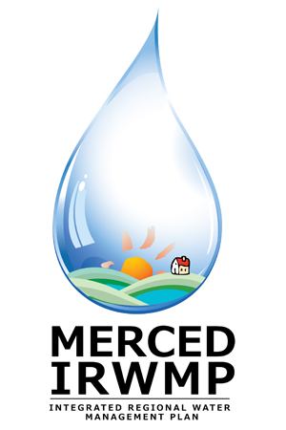

Merced Integrated Regional Water Management (IRWM) Plan
Regional Advisory Committee Meeting #9
Tuesday January 22, 2013
2:00 pm – 5:00 pm
Public Health Auditorium
1st floor of the Department of Public Health
260 E. 15th Street
Merced, CA 95341

- Introductions and Overview 15 Min
- DWR Update 5 Min
- RAC Activities and Materials 20 Min
  - December 18 Notes
  - Comments on the Technical Studies
  - February Public Workshop
- Workgroup Reports 20 Min
  - Disadvantaged Communities
- Summary of Technical Studies 30 Min
  - Salt and Nutrient Management
- Data Management, Technical Analysis, Plan Performance Approach 50 Min
- Implementation Grant Update 30 Min
- Next Steps 5 Min
- Public Comment 5 Min

